1. Create project (flipkart), change directory and open project in vs code

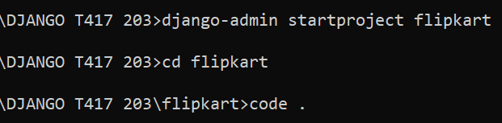

1. Create application (product)



1. Register application in settings.py

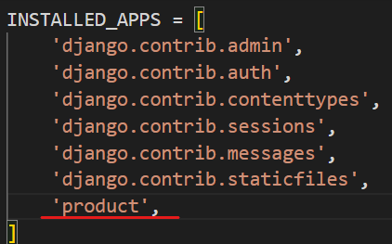

1. Create templates folder at project level
   1. Create product folder in templates folder
   2. Create index.html file in product folder

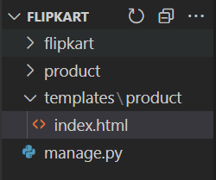

1. Register templates folder in settings.py

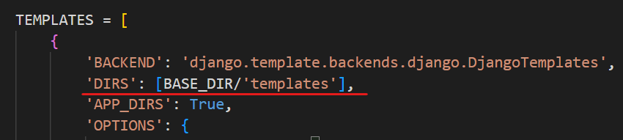

1. Create database – flipkart from workbench

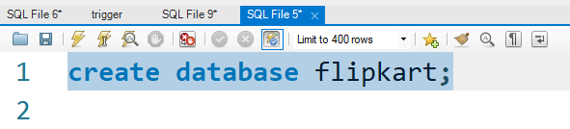

1. Add database details in settings.py (NAME,USER,PASSWORD,HOST,PORT)

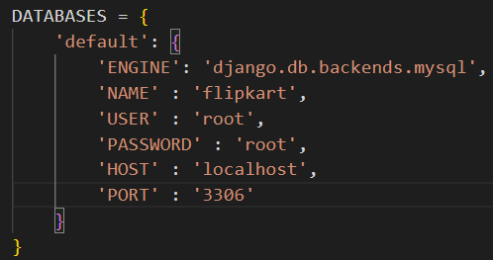

1. Runserver : if you are not getting any error then django is connected with database

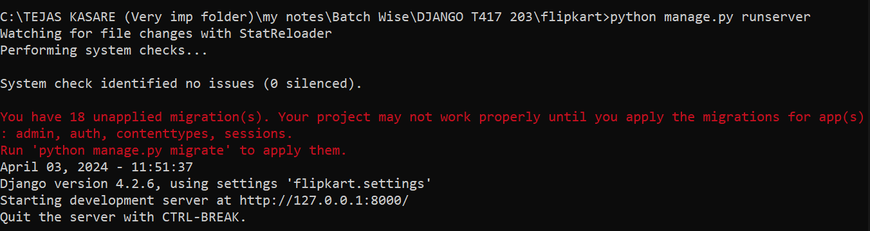

1. Create Product model class in models.py

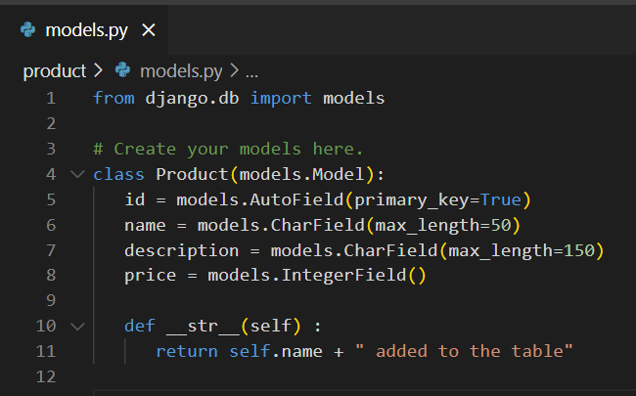

1. Register Product model class in admin.py

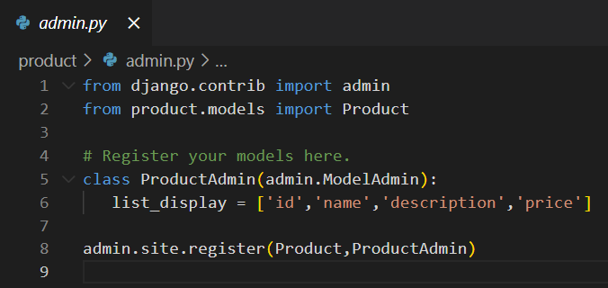

1. Covert model class into respective sql query : makemigrations

>*python manage.py makemigrations*

1. To execute query created by makemigrations : migrate

>*python manage.py migrate*

1. Check tables in flipkart database

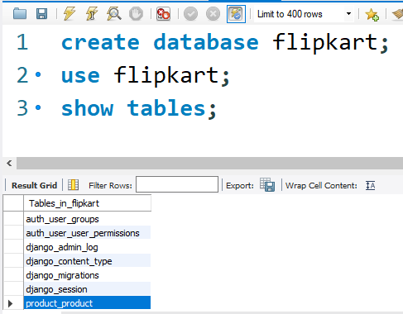

1. Create superuser

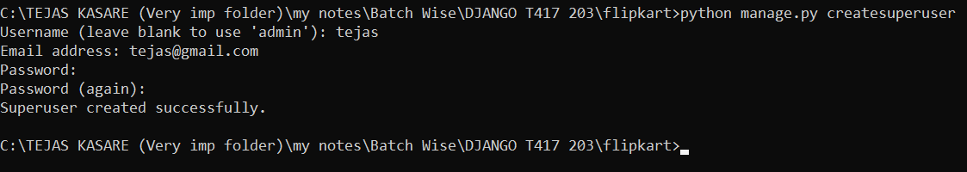

1. Runserver and Use above credentials to login admin panel *http://127.0.0.1:8000/admin*
2. Add some products

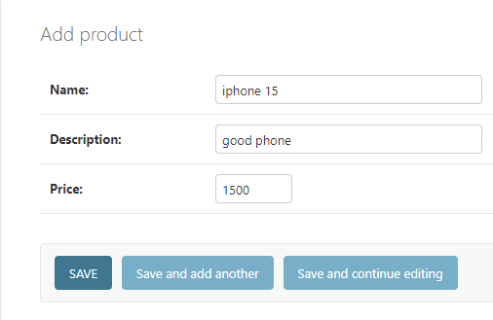

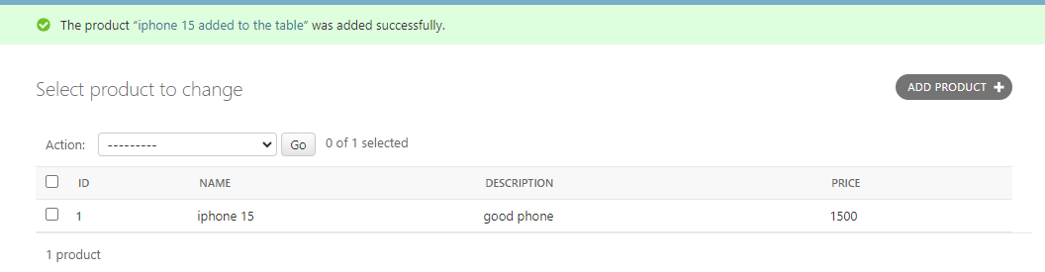

1. Create view – show_products() in product > views.py
   1. Write code to fetch all products from Product model
   2. Send fetched products to index.html

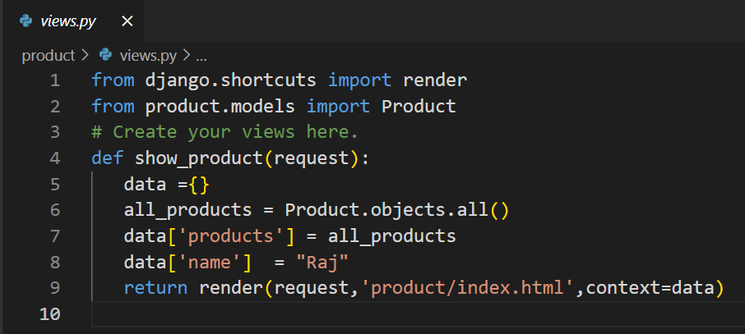

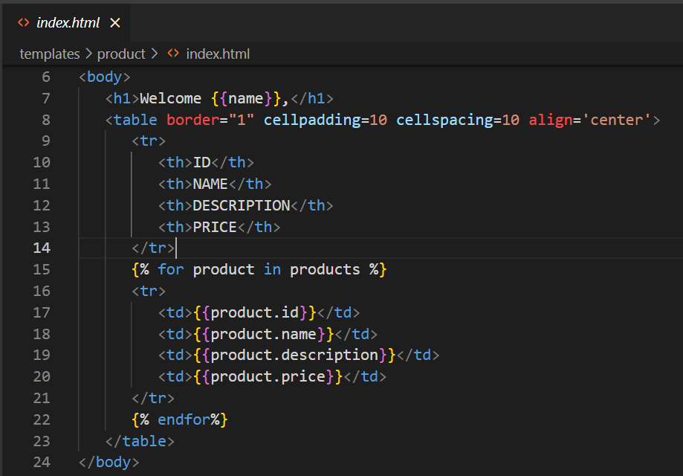

1. Create url at application level and add it to the project level (urls.py)
   1. Create product_urls.py in product
   2. Code
   3. Register product_urls.py in urls.py (project level)

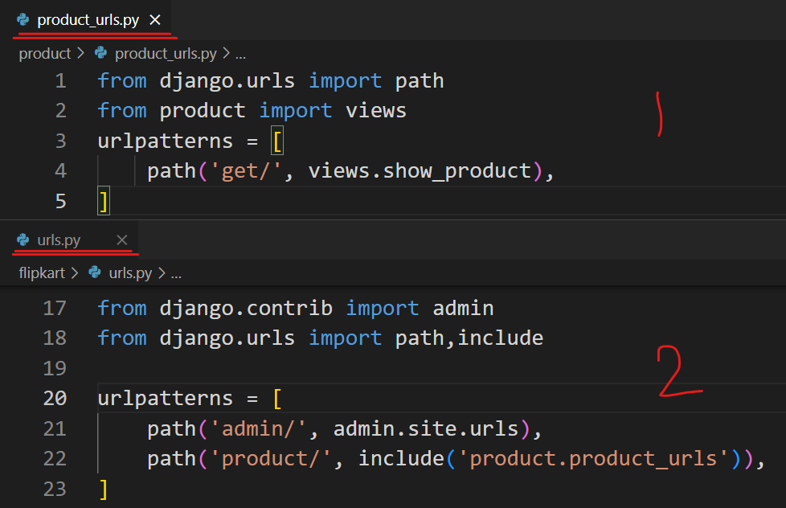

1. Runserver and get Output

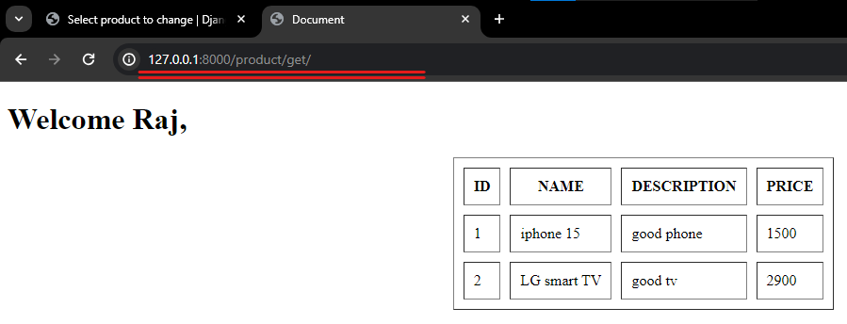

1. Working with static files (CSS and Images)
   1. Create static folder at project level (like we created templates)

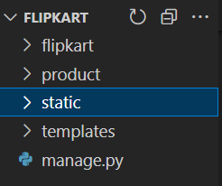

* 1. Register static folder in settings.py

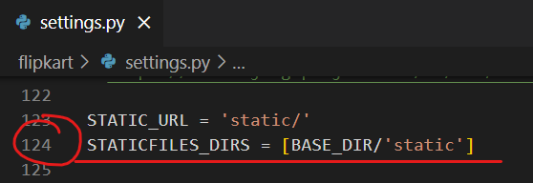

* 1. Create css and images folder in static folder

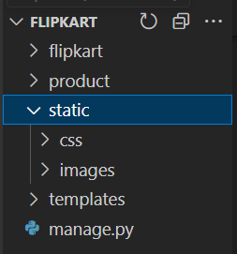

* 1. create style.css in above css folder and add one image in images folder

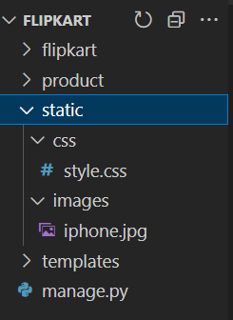

* 1. you can get above image through url on the browser as –

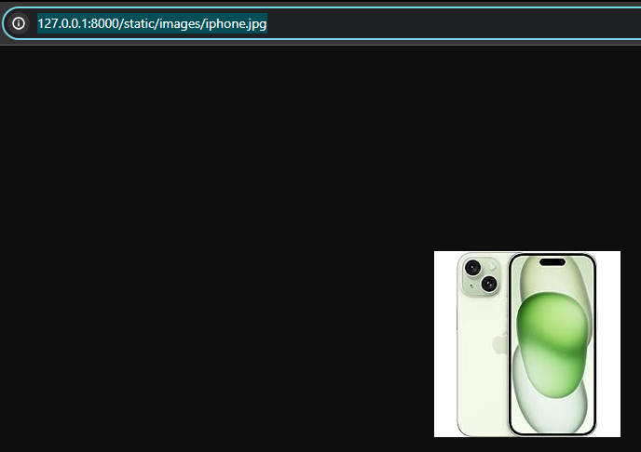

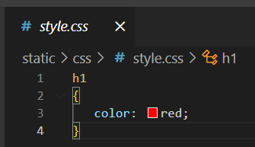

* 1. configure style.css in display image in index.html

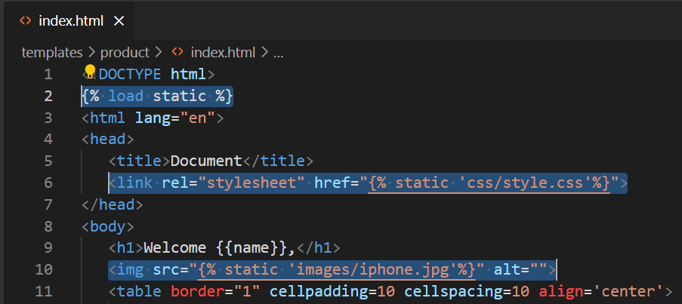

1. output

